**Voice command, UI tweaks, and additional accessibility settings are all part of a new PS5 software beta update.**

Select users in the United States, Canada, Japan, the United Kingdom, Germany, and France will receive system software betas today.



Why it matters: Sony has released a beta version of a new PS5 system software that offers additional ways to customise your gaming experience, including new party options, accessibility capabilities, and UI improvements. There's also a new PS4 beta update featuring open parties and the ability to set individual party member loudness.

Sony's new system software upgrades [enable](https://blog.playstation.com/2022/02/08/new-ps5-and-ps4-system-software-betas-roll-out-tomorrow/) users create open and closed parties for PlayStation 5 and PlayStation 4. To join an open party, users must have the same software version (currently beta), but anyone can join a close party regardless of their software build. Friends and family can join an open party without invitation. However, only those invited by the creator are allowed to enter closed parties.

PS5 beta users will be able to identify the person speaking in voice chat with the help of new visual indicators. They can also use the Share Play feature directly from their voice chat window. PS4 users can also adjust the volume of each party member's voice chat, just like PS5 users.

The PlayStation 5 Game Base will undergo a minor redesign. Voice chats are now called parties, and the menu is divided into the Friends, Parties and Messages tabs. You can now access friend requests and view/search for friends in the Game Base control menu. This menu allows users to add or remove players from groups and create new ones. This menu also contains text, quick messages, images and videos as well as the ability to view a group's shared media.

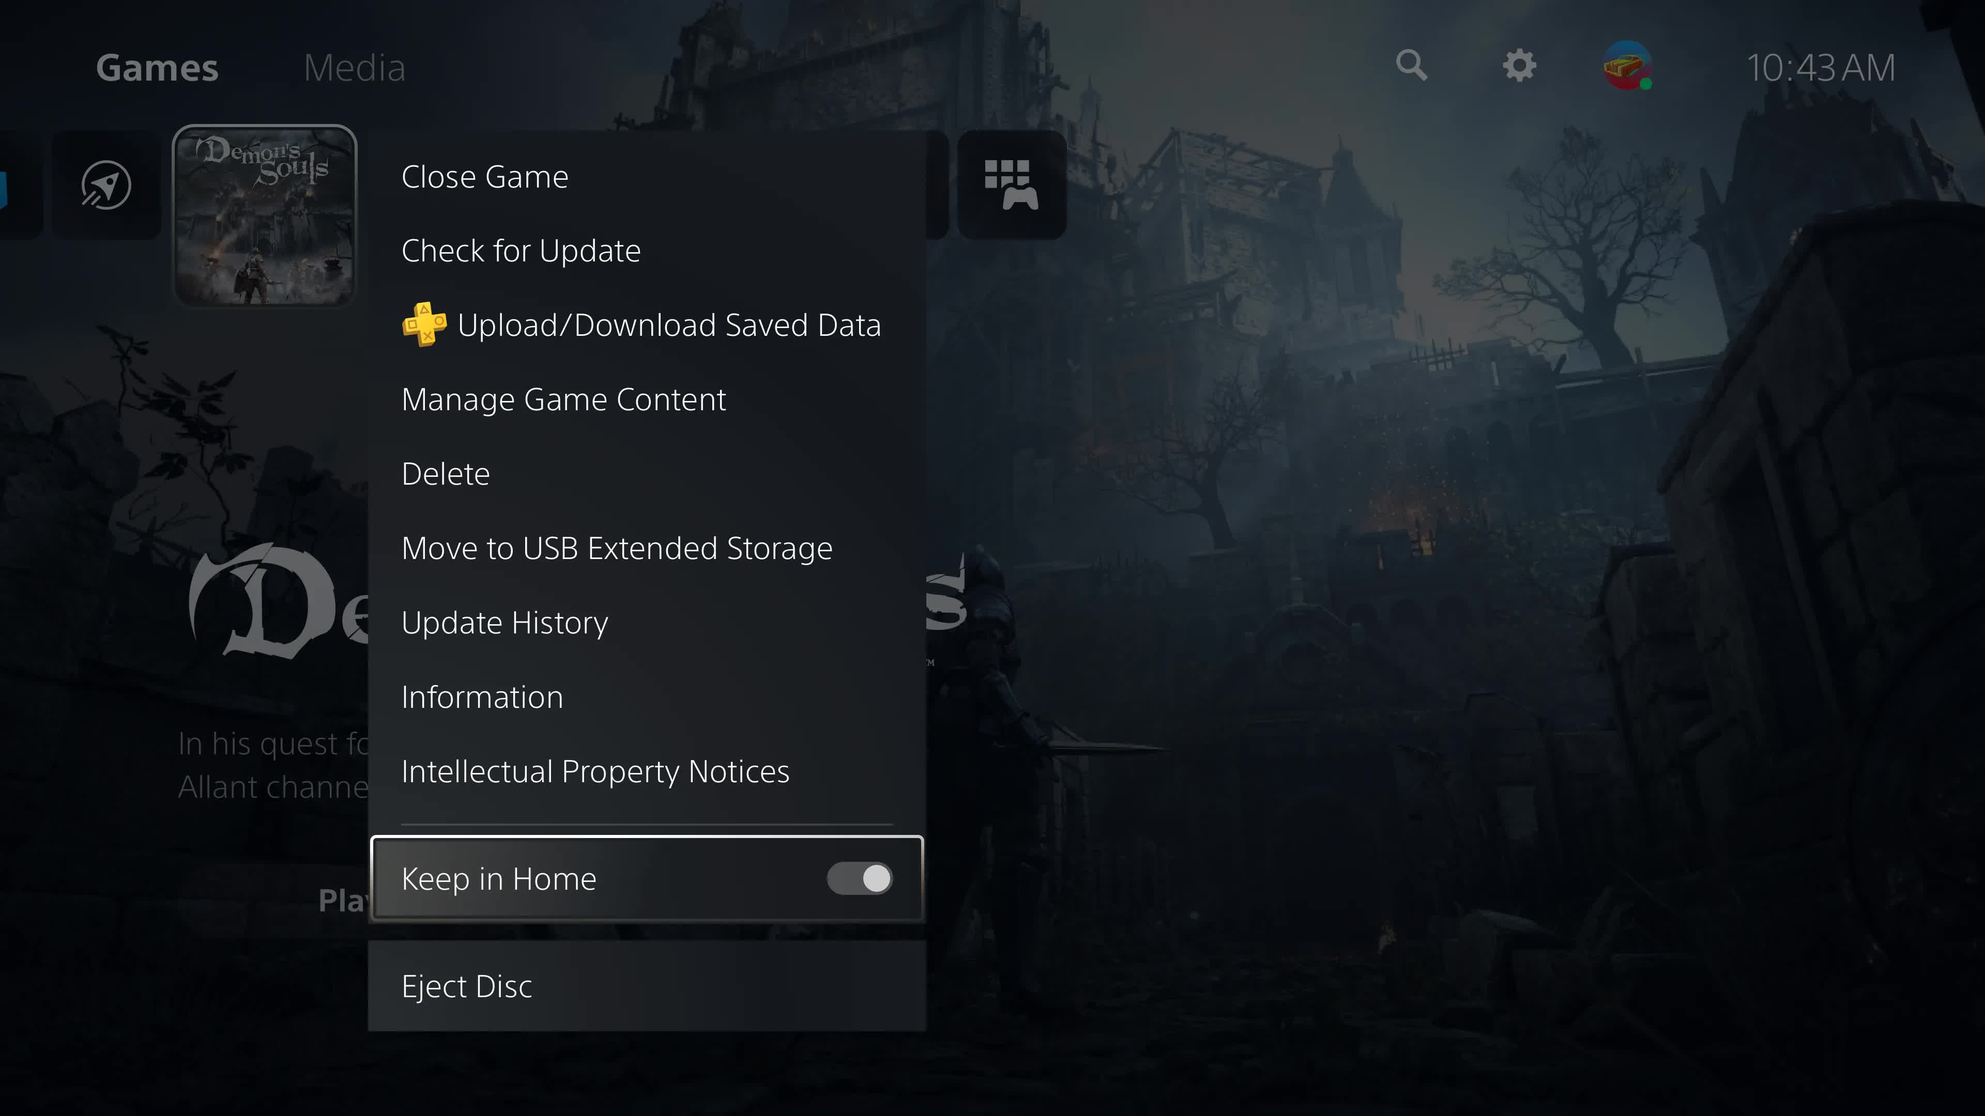

Other minor adjustments include an icon for users who share their screens, and a decline button for the friend request list.

The console's interface has been updated with a game genre filter for your game collection, and an "Keep in Home” option to add apps and games to the home screen. This option allows you to have up to five apps or games enabled. However, the home screen supports a total 14 apps and games.

Sony also updated its trophies UI. Users can now see suggestions and get it from the Control Center, while they are playing. Users can also share their screens via the Create menu.

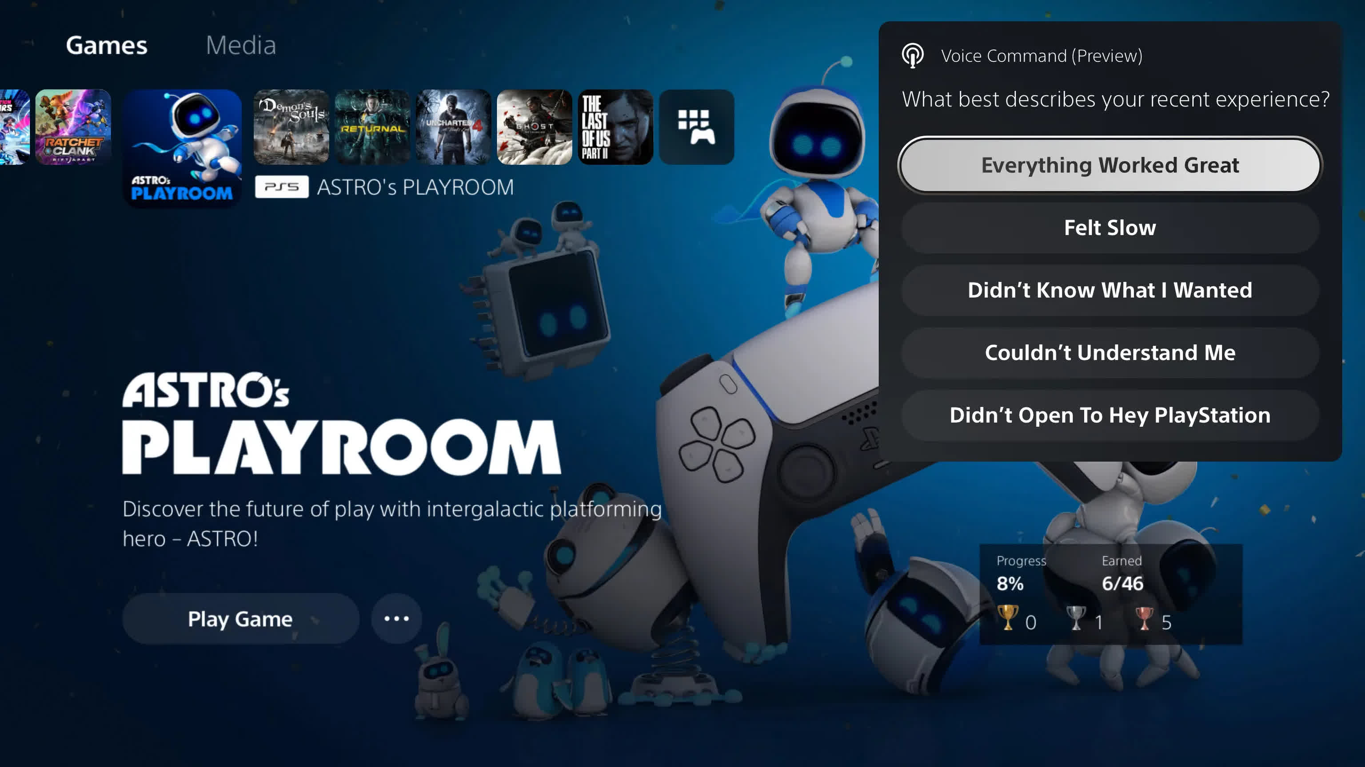

The latest PlayStation 5 beta update supports six additional languages for Screen Reader: Russian, Arabic and Polish. The update also allows you to turn on mono audio for headphones and displays check marks for enabled options.

The Voice Command (preview) is a potentially more exciting addition. It's a voice assistant for the PS5 that is geared towards console tasks. It will let users open apps, games, settings, and manage media playback. Beta users will need to enable this feature via the settings menu in order to test it. It activates by saying "Hey PlayStation!" It then issues a command, such as asking for video playback control or searching for something.

Sony invites you to give feedback on this feature. This feature may record your voice commands. You can opt out of having your recordings uploaded to Sony by turning off the Voice Command (preview).

Only owners in the US, Canada Japan, UK, Germany and France will have access to the beta software. The Voice Command preview will also be available only to select US and UK-based users. This update's final version will be released later in the year.